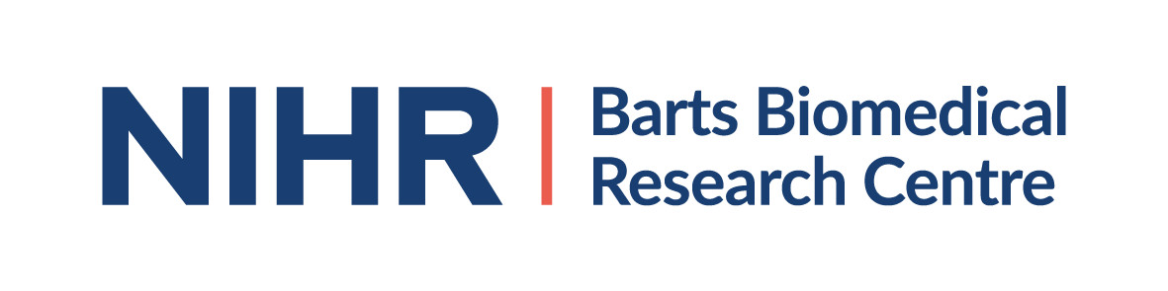

Barts Biomedical Research Centre

Let’s Talk Hearts
15 October 2019 3.30pm-5.30pm Bromley by Bow Centre
St Leonard’s St, London E3 3BT

Agenda

3.30pm Dr Sucharitha Chadalavada, Clinical Research Fellow, QMUL
Diabetes and the Heart

4.00pm Community Smiles (Barts and The London School of Dentistry)
Oral health awareness: Links between Gum Health, Heart Diseases and Diabetes

4.30pm Dr David Collier, Clinical Director - William Harvey Clinical Research Centre, QMUL
Aim High – Why Ethnicity and Blood Pressure Matters

5.00pm Questions and Answers

5.30pm Close

